

Colorado OWTS Soil Site Evaluation Report
775 Lake View Rd, Westcliffe, CO 81252
Rusty (719) 371-1061
Rusty@Caldwellfamilyconcrete.com

Isaiah 28:16 – “See, I lay a stone in Zion, a tested stone, a precious cornerstone for a sure foundation; the one who relies on it will never be stricken with panic.”
CALDWELL FAMILY CONCRETE, LLC
Project Information
Project Name: Turkey Toe
Project Address: 184 County Road 130
Westcliffe, Colorado 81252
Property Owner: Devon Tilly
Mailing Address: 5330 E. 6th Avenue Parkway
Denver, Colorado 80220
Email: devon@gdinvest.us
Prepared By: Caldwell Family Concrete, LLC
Site Description
The property was evaluated for installation of a proposed Colorado Onsite Wastewater Treatment System (OWTS). Two soil profile pits were excavated within the proposed soil treatment area to evaluate soil texture, structure, groundwater conditions, and limiting layers. The site consists of gently sloping native terrain with grasses and sagebrush. Surface drainage is positive and no evidence of ponding or erosion was observed.
Field Investigation
Investigation Date: July 2026
Number of Profile Holes: 2
Excavation Equipment: Kubota KX040 Hydraulic Excavator
Maximum Exploration Depth: Approximately 8 feet (96 inches)
Soil texture was classified in the field using the USDA Texture-by-Feel Method.

Soil Classification
Parameter | Observation
USDA Texture | Loamy Sand
Colorado Soil Type | Type 2
LTAR | 0.60 gallons/day/square foot
Drainage Class | Well Drained
Restrictive Layer | None Observed
Bedrock | Not Encountered to 8 feet
Groundwater | Greater than 8 feet below grade
Redox Features | None Observed
Mottling | None Observed
Soil Horizons
A Horizon (0–8 inches)
Dark reddish-brown loamy sand containing organic matter and fine roots.
Bw Horizon (8–24 inches)
Reddish-brown loamy sand with weak subangular blocky to single-grain structure and scattered gravel.
C Horizon (24–96 inches)
Light reddish-brown loamy sand with scattered gravel and weathered rock fragments. The horizon remained uniform to the full depth of exploration. No restrictive layer, bedrock, groundwater, seepage, mottling, or redoximorphic features were observed.
Profile Hole Observations
Profile Hole No. 1: Excavated to approximately 96 inches. Uniform loamy sand profile with excellent drainage. No groundwater, bedrock, or restrictive layer observed.
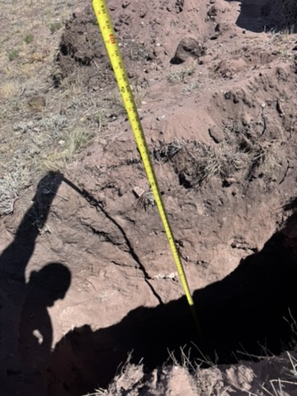

Profile Hole No. 2: Excavated to approximately 96 inches. Soil conditions consistent with
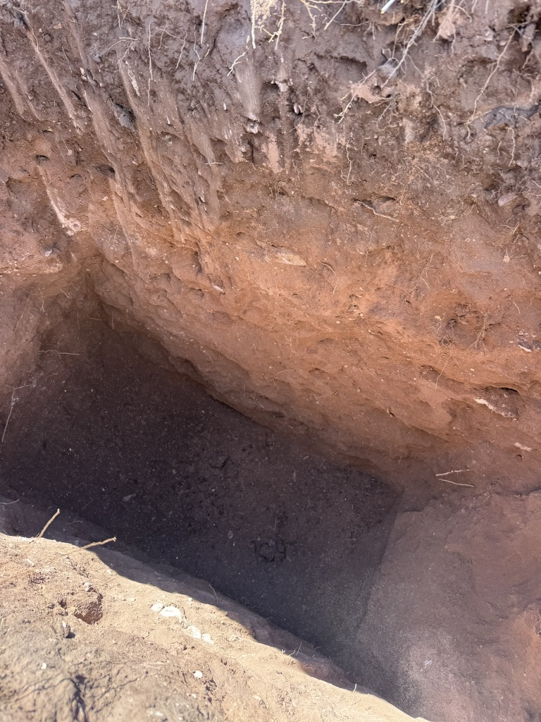

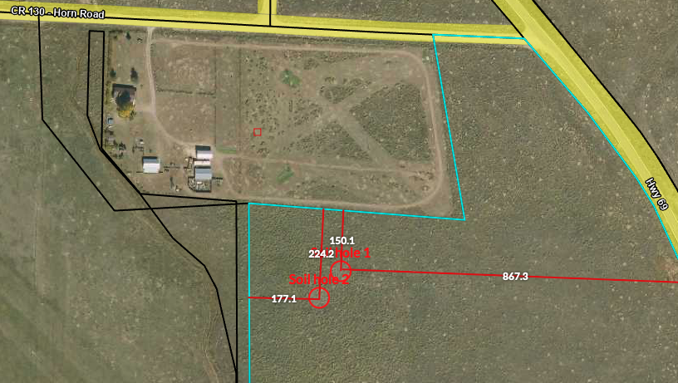Groundwater Evaluation
Groundwater was not encountered in either profile hole. The observed groundwater level is greater than 8 feet below existing grade. No seepage, perched water, mottling, or redoximorphic features were observed.
Conclusions
The site is classified as USDA Loamy Sand (Colorado Soil Type 2) with an LTAR of 0.60 gallons/day/square foot. The soil profile is well drained and suitable for a conventional OWTS absorption field, subject to final design and approval by the Authority Having Jurisdiction.
Prepared By
Rusty Caldwell
Caldwell Family Concrete, LLC

